Intermediate Value Theorem Name_______________
Big D and Puff Daddy Math Publications Class_______________

- f is a continuous function
f(0) = 5 and f(3) = 10
Which of the following is guaranteed by the intermediate value theorem?

- f(c) = 6 for at least one c between 5 and 10
- f(c) = 2 for at least one c between 0 and 3
- f(c) = 2 for at least one c between 5 and 10
- f(c) = 6 for at least one c between 0 and 3

2) For the equation
f(x) = ${(x-3)}^{2}+3$, in the interval [3,5], and y = 4
Explain why the intermediate value theorem works and show this graphically, then find a value of c in the corresponding interval that is exactly equal to the given y value
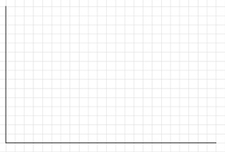

(c)2019 Big D and Puff Daddy Co. All Rights Reserved

