Rose Curve
Open the TI-Nspire document §13-4 Rose_Curve.  In this activity, you will explore the effect of changing the parameters a and n in the curve r = a*sin(nθ) and r=a*cos(nθ). You will also explore the relationship between the rose curves and their functions. | 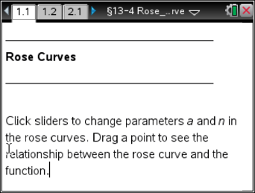
Move to page 1.2.
1. A polar curve with an equation in the form r = a*sin(nθ) or r=a*cos(nθ) is called a rose curve. Why do you think this is so?

2. Press £ and ¤ to change the value of n in the equation r = asin(nθ).
a. What effect does the value of n have on the graph of the curve?

b. Explain what happens to the curve when you increase and decrease the value of n.

3. How many petals does the curve have when n = 3? When n = 4? Predict the number of petals when n = 9 and when n = 10.

4. Write a rule/equation to predict the number of petals of a rose curve.

5. Press £ and ¤ to change the value of a in the equation r = asin(nθ). Explain the effect that the value of a has on the graph. Be sure to include a description of what happens to the curve when you increase and decrease the value of a.

6. Explain how your knowledge of sinusoidal functions can help you understand the effect the value of a has on the graph of a rose curve.

Move to page 2.1.
7. Grab point P (located at the origin) and slowly drag it along the function y = 3sin(2x), 0 ≤ x ≤ 2π. As you drag point P, you will see the polar curve r = 3sin(2θ), 0 ≤ θ ≤ 2π also being sketched.
a. Explain the effect of the coefficient 2 on the graph of each of the two curves.

b. What part of the rectangular graph of the function corresponds to the first quadrant petal in polar coordinates? Generalize this idea for all four petals of the curve.

c. What effect does the coefficient 3 have upon the graphs of each of the two curves?

Move to page 2.2 to answer Question 8.
- What is the equation of a rose curve that would be formed if we dragged point P along the function y = 5sin(4x)?

Move to page 3.1 to answer Questions 9 and 10.
- Repeat #2-#7, this time using the equation r=a*cos(nθ). Record your answers below in an organized fashion.

10. What similarities/differences do you note between the rose curves formed by the sine and cosine?

Move to page 4.1.
11. Drag point P along the function y = 3sin(3x), 0 ≤ x ≤ 2π. As you drag P, the polar curve r = 3sin(3θ), 0 ≤ θ ≤ 2π will be sketched. Explain why the polar curve r = 3sin(3θ) has only three petals, while the function y = 3sin(3x) has six arches. [Pay attention to HOW the polar curve graphs – which petal is graphed 1st, 2nd, etc.]

Move to pages 4.2 and 4.3 to answer Questions 12 and 13.
- What is the equation of a rose curve that has 12 petals, each of length 10?

- What is the equation of a rose curve that has 5 petals, each of length 6?
Summary:
14. Write a paragraph summary of what you now know about rose curves. Include equations, characteristics, symmetries, etc.

